**Google vs Apple - Who did it better?**

The purpose of our project is to gather and analyze information on apps in the Google Play Store and the Apple App Store in order to see who runs a more successful applications store by, free vs. paid, user rating, and categories.

We collected information on over 8,000 apps across different categories in the Google App Store and over 7,000 apps in the Apple App Store. We focused on the following 8 common categories: Education, Entertainment, Health & Fitness, Games, Productivity, Photo & Video, Utilities and other.

**Questions**

**Category**

Which Category has the highest share in the stores?

* In order to better compare between Apple store and Google Play store, we did re-categorizing of all the apps into 8 common categories based on their original categories in each store. It appears that in Google Play store, Utilities, Games and Entertainment all have high shares on the market while in Apple Store, Games has the dominant prevalence, which shows a difference in market strategy between the two companies. Apparently, mobile gaming is Apple’s top focusing and Google is trying to be an all-rounder.

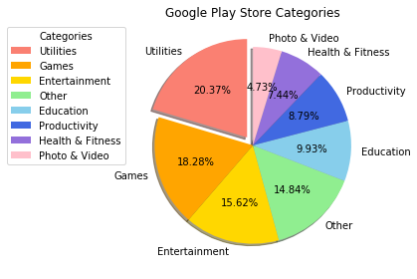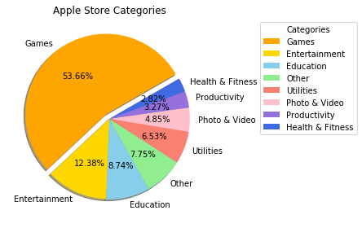

What is the distribution of Free and Paid apps in the stores?

* We picked the four categories (Games, Utilities, Entertainment, Education) to do a comparison in terms of the distribution of Free and Paid apps in each store. The results showed that in Google Play Store, the majority of the apps are free. In Apple Store, almost half of the apps are paid app. It seems that Google Play Store is a better choice for whoever doesn’t want to spend money on apps.

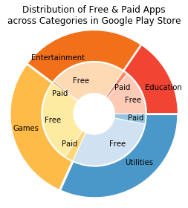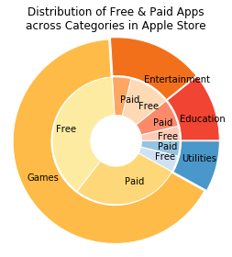

**Price**

Does Category affect Price?

* Between the 8 categories we compared the average prices to see if category effects price. Looking at the data Apple apps were much more expensive on average than Google Apps.

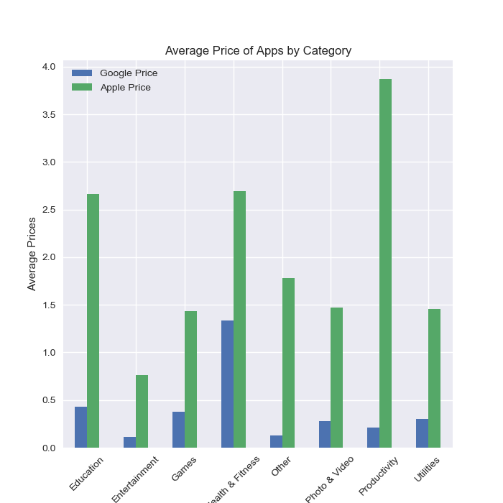

Does rating correlate to Free or Paid (Does the quality matter)?

* We grouped the applications by whether they were paid or free from that we compared the average rating of the groups to determine if any trends exist. Based on the data paid apps in both stores were rated better overall

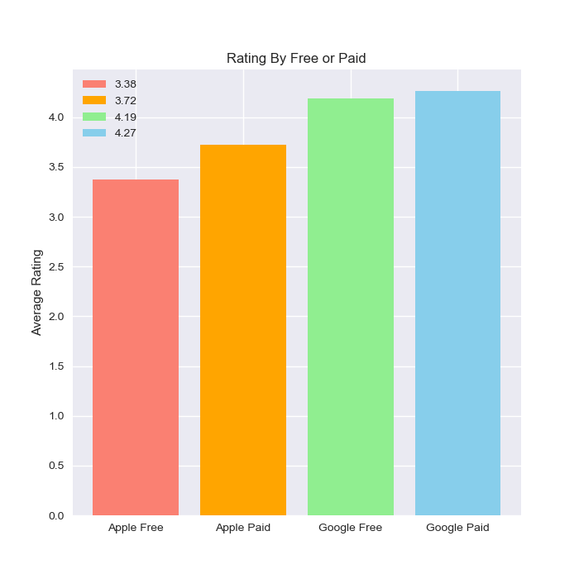

**Rating**

Does Category affect rating? Are there categories that perform really good or bad?

* We tried to run a one way ANOVA test and confirmed that the p value is significantly small for both stores. Google Play store’s p- value came out to 2.32 e-20 and Apple App store’s p-value came out to be 5.32 e-36. The average app ratings across categories appears to be very different.

Google Play Store

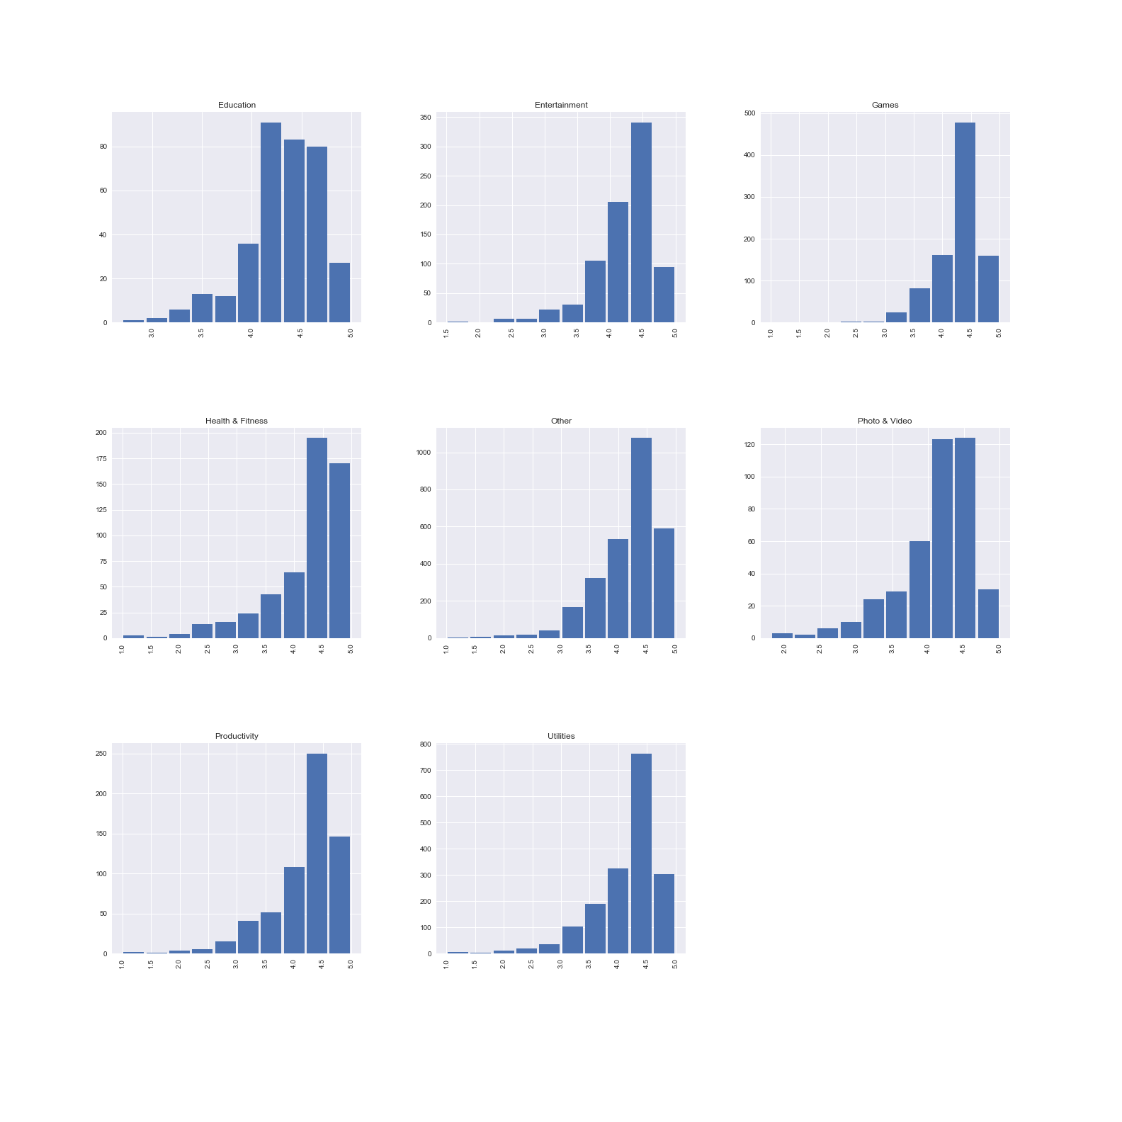

Apple App Store

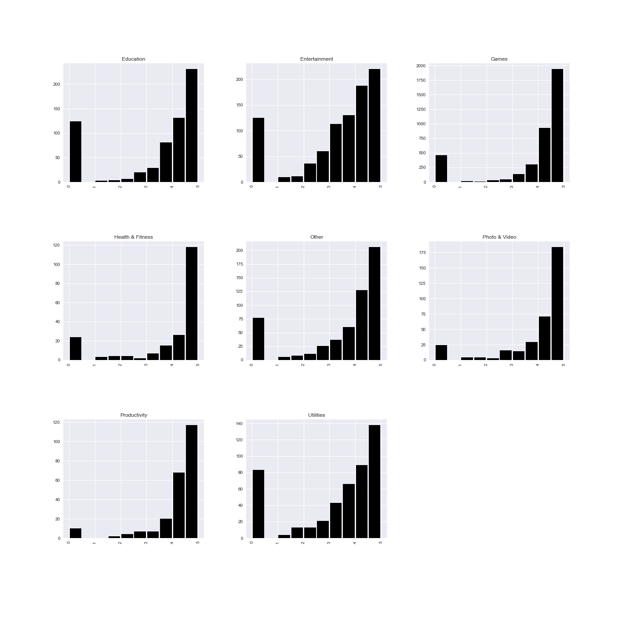

Between the two markets who has better Apps, rating wise?

* We were able to find that Google Play Store seems to have a better Average rating of 4.17 as opposed to the Apple App Store that has the rating of 3.53. Based on this finding, it appears that the Google Play Store has better apps.

